Ideation Phase
Empathize & Discover
Date | 31 January 2026
Team ID | SWTID-2026-1597
Project Name | AI Fit Track API – Personalized Fitness Tracking with AI-Powered Insights
Maximum Marks | 4 Marks

Empathy Map Canvas:
The empathy map below captures what our primary persona, Meera – a working professional trying to stay consistent with fitness – says, thinks, does and feels, along with her pains and gains.
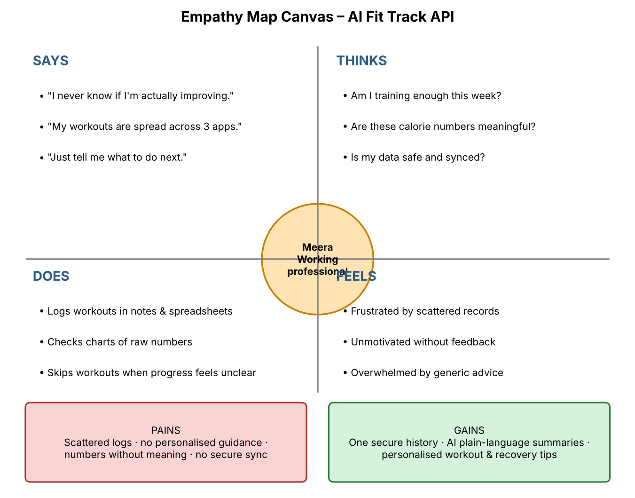
Figure 1: Empathy Map Canvas for AI Fit Track API
Quadrant | Observations
Says | "I never know if I'm actually improving." / "My workouts are spread across three apps." / "Just tell me what to do next."
Thinks | Am I training enough this week? Do these calorie numbers mean anything? Is my data safe and synced?
Does | Logs workouts in notes and spreadsheets, checks charts of raw numbers, skips workouts when progress feels unclear
Feels | Frustrated by scattered records, unmotivated without feedback, overwhelmed by generic advice
Pains | Scattered logs, no personalised guidance, numbers without meaning, no secure cross-device sync
Gains | One secure history, AI plain-language progress summaries, personalised workout and recovery recommendations

